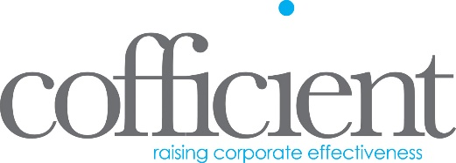

Job Title: Senior Financial Consultant
Location: Glasgow, with options for remote work
Type: Full-Time
About Us: Cofficient Ltd is a dynamic and growing company specialising in providing innovative software solutions. Due to exciting business expansion, we are seeking a talented and passionate Senior Financial Consultant to join our multi-disciplined team. If you're looking to be a part of a forward-thinking team and work on cutting-edge projects, we want to hear from you.

Role Overview:
As a Senior Financial Consultant, you will play a pivotal role in providing key financial consulting services throughout the implementation, support, and post-go-live phases of our software solutions. Your expertise will ensure that our clients receive top-notch service and support, helping them to optimise their financial processes and systems.

Key Responsibilities:
- Conduct workshops and presentations to analyse and understand key business processes.
- Identify functional gaps within client systems and propose effective solutions.
- Assist in testing, training, and data migration to ensure a smooth implementation process.
- Provide ongoing support to existing clients, addressing escalated queries or issues with financial processes and systems.
- Work closely with clients' key users to maintain a strong, supportive relationship post go-live.

Requirements:
- Fully qualified accountant (CA, ACCA, CIMA, ACA, or equivalent) with at least 5 years of commercial experience.
- In-depth knowledge of financial processes within a commercial organisation.
- Proficiency in data analysis and rationalisation.
- Advanced skills in Microsoft Excel.
- Ability to meet tight deadlines and work efficiently under pressure.
- Excellent written and oral communication skills, with the ability to effectively communicate with both technical and non-technical stakeholders.

Desirable Skills:
- Experience with HR processes and the deployment of HCM solutions.
- Previous experience in data migration projects.
- Prior customer-facing role experience.
- Knowledge of database management and structure.

Why Join Us?
- Opportunity to work on leading-edge projects in a fast-paced and innovative environment.
- Be part of a supportive and collaborative team.
- Continuous learning and development opportunities.
- Competitive salary and benefits package.

How to Apply:
Please send your CV and a cover letter explaining why you are the perfect fit for this role to careers@cofficient.co.uk . We look forward to hearing from you!

